[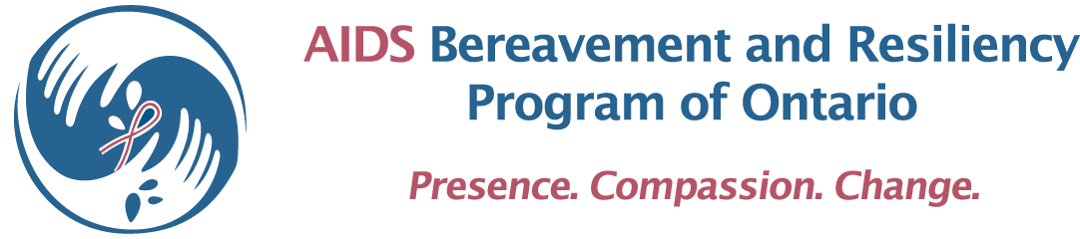](http://abrpo.org/)

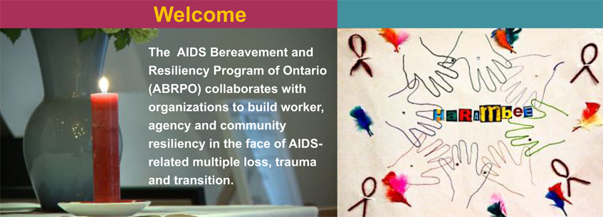

**[Programs](http://abrpo.org/)**

[Basic Training](http://abrpo.org/program/basic-training/)

[When Grief Comes to Work](http://abrpo.org/program/basic-training/)

[Resiliency Initiative](http://abrpo.org/program/resiliency-initiative/)

Turning To One Another

Network

ABRPO will continue to assist:

* workers to maintain high levels of human service
* organizations to retain invaluable professional staff and volunteers, including board members
* communities to respond effectively to the diverse groups now requiring support.

We have been helping ASOs and other AIDS-serving organizations in Ontario strengthen resiliency in the face of multiple loss and grief since 1994. Contact us to create a program that is tailored to your organization’s needs. ABRPO’s programs are fully funded by Ontario’s Ministry of Health and Long Term Care, AIDS Bureau.

Survive & Thrive

Project Sustain

[](http://www.hivresourcesontario.ca/)

Click on the link to visit our website: <http://abrpo.org/>